Laporan Praktikum 6

1. Source code

ModelUser.php -> model

ModelBuku.php -> model

1. Capture Database
2. Table Buku

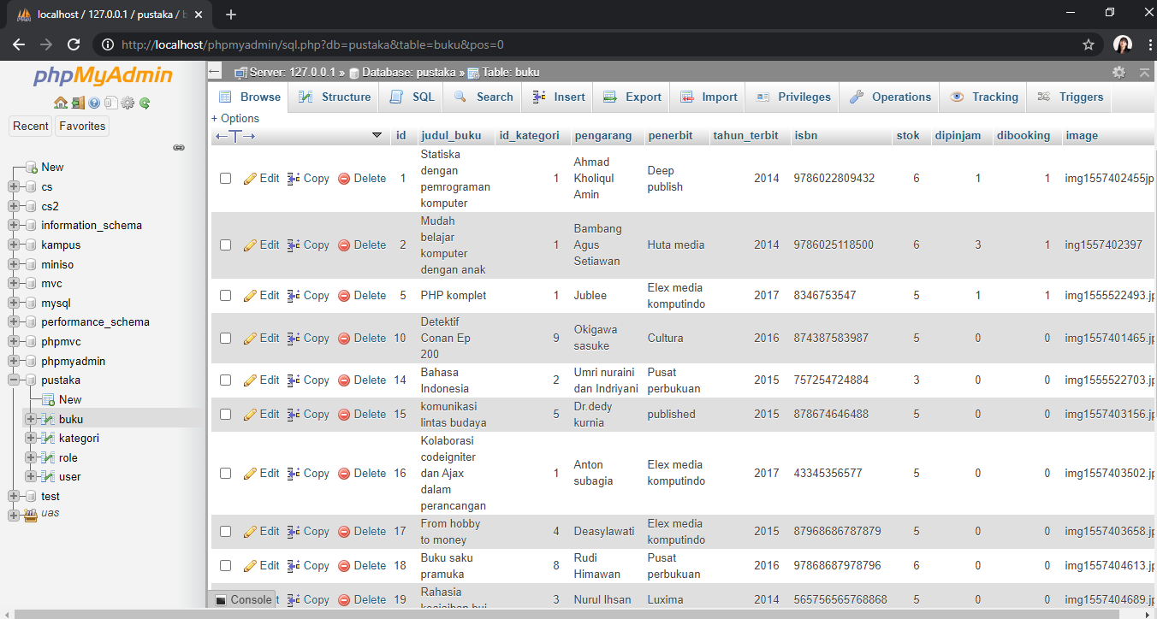

1. Table Kategori

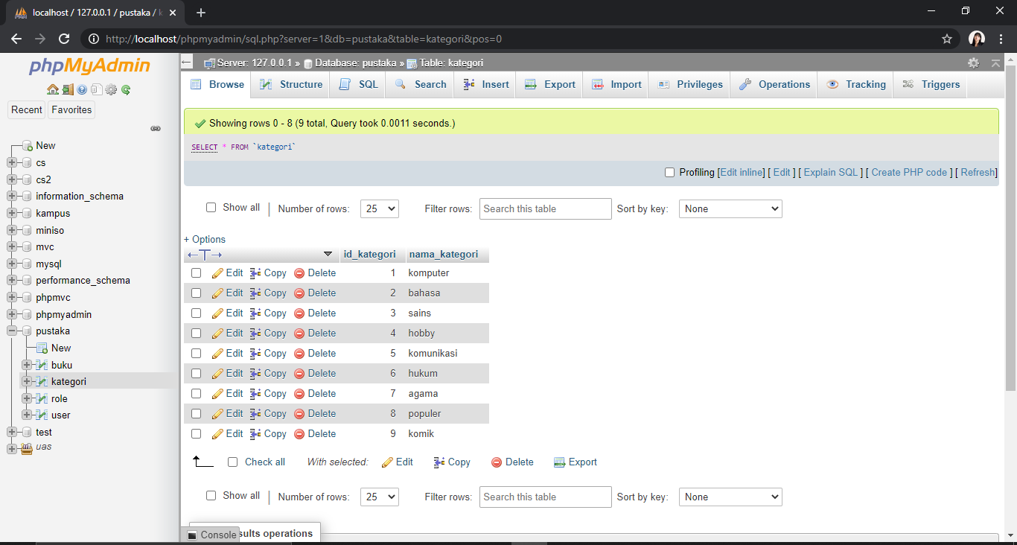

1. Table Role

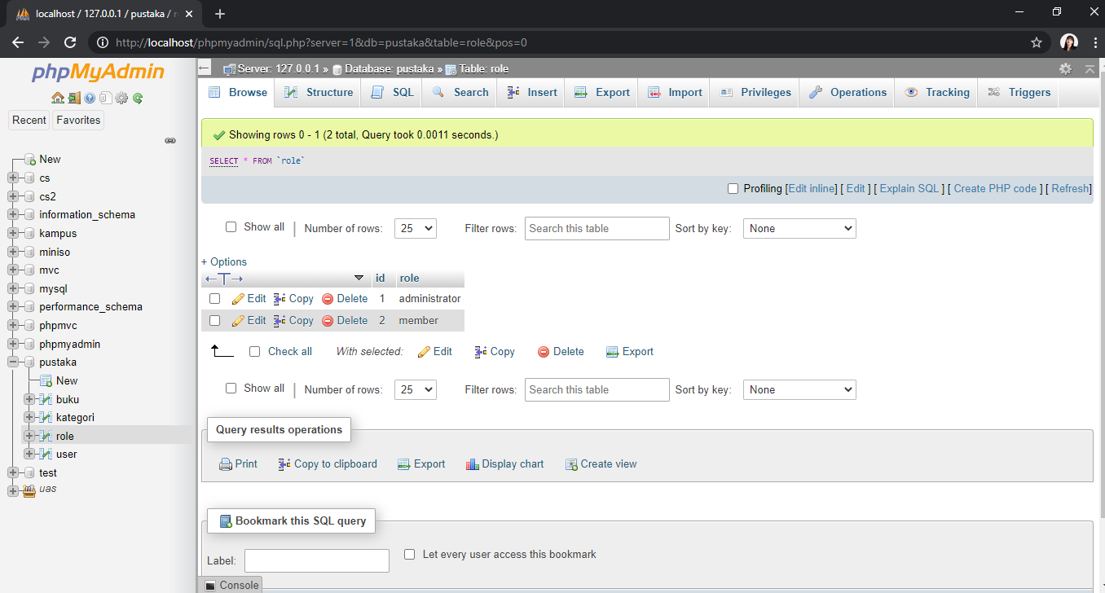

1. Table User

